
Special Educational Needs Inclusion Service
SLD
Playing Games
- Playing games is great for learning social skills
- Good to develop confidence
- Good way to build relationships

Playing games is a fantastic way to practice social skills for all children. Using various support materials, this will aid your children to enjoy the experience and learn lots of new skills.

Things to think about:
- The language used e.g. ‘my turn’ and ‘your turn’. Start with something your child is used to, such as throwing a ball or blowing bubbles. This way there are no winners and losers. When successful, you can add in more players.
- Think about a game that everyone can be successful at and enjoy playing.
- Time- play a game that the child has enough attention to play and contain interest.
- Think about games that your child can play with their siblings.
- Have fun!

Turn taking:

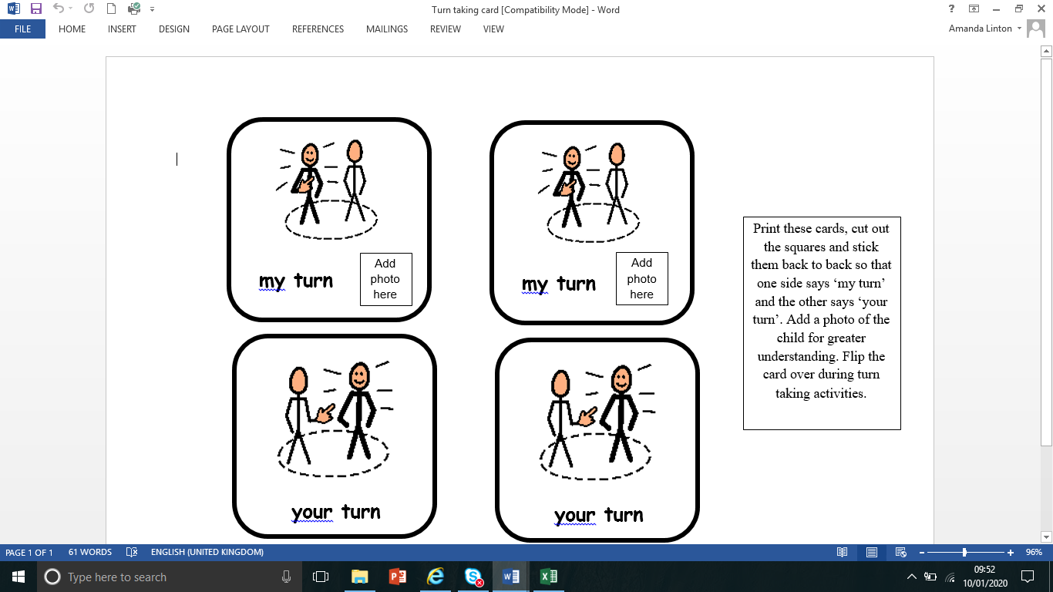

This is a card which has symbols for my turn and your turn on it. You can add a photo of your child in the space. When it is their turn, their photo faces up, and when it is someone else’s turn, flip it over so his photo faces down. This will support your child in understanding the concept of turn taking.

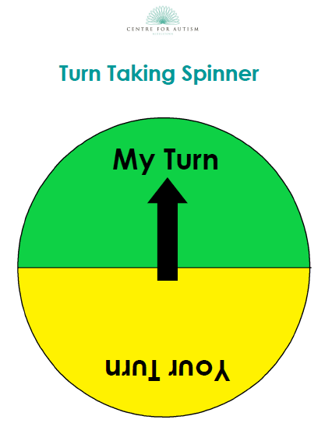

This turn taking spinner by Middletown Centre for Autism can be used to play games or taking turns such as going on a slide. You can print it out and add a split pin.

You can access turn taking spinner at Middletown Centre for Autism.

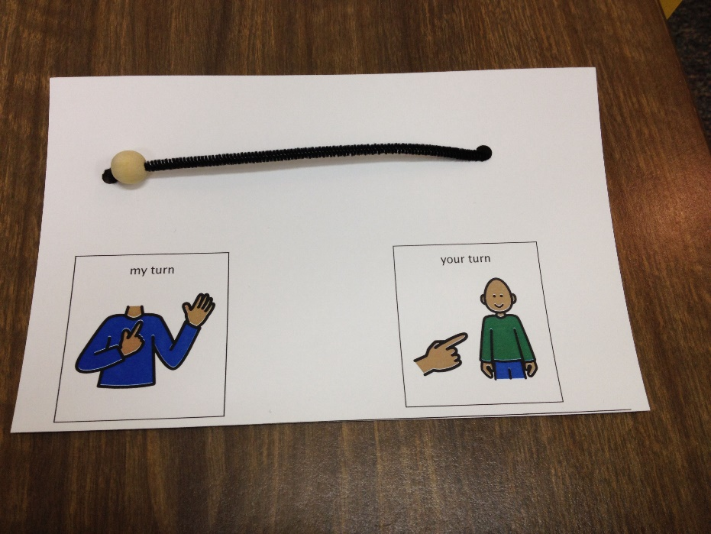

This idea can be used with visuals or photographs. You move the bead between the players. You can also add photographs.

Wait card
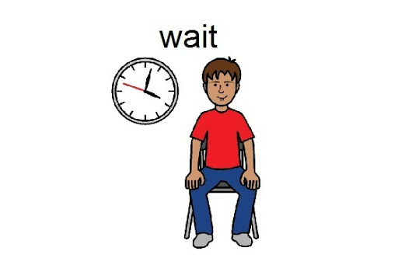
When playing a game, if the child has to wait a considerable time, you may wish to use a wait card. When the child has to wait, present your child with the wait card, verbally say “wait” and sign if necessary. Additionally, you can use a timer so your child can visually see how long they have to wait for. Once the child no longer needs to wait, remove the wait card and praise your child for good waiting. Then give your child the instruction.

Help cards
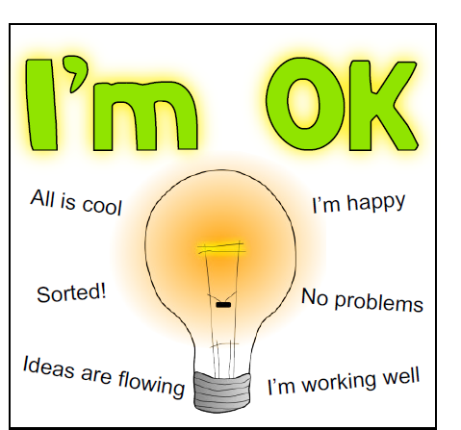
Your child may wish to use a help card. This would be useful to develop your child’s confidence and independence. At the start of the game, give your child the help card. If your child needs help, teach your child to turn over the card when the need help. Remember to give them praise. The card can be made double sided.
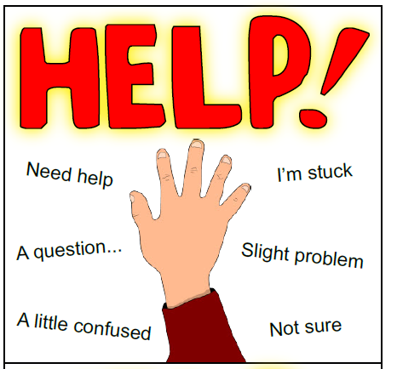

At the end of the game
- Encourage everyone to say well done to the winner.
- Remind the child that they may win the next time.
- Praise everyone for taking part.
- You may wish to show your child the All Done Visual, verbally say and sign if appropriate.


Social Stories
Social stories are a good resource to help your child understand about winning and losing. This is an example which can be adapted to your child.

Sometimes I Win,
Sometimes I Don’t!

My name is __________. I like to play with my friends. We like to play games and we like to have fun!

I play games with my friends in my classroom, in the playground or at home.

Some of the games that we play have Winners!

Sometimes, I am the winner of the game. I like winning the game. It feels great!

Sometimes I’m not the winner of the game. My friend is the winner instead.
This is great too! I can be happy for my friend.

When I’m not the winner, there’s no need to worry! It’s ok not to be the winner every time.

When I don’t win, I can . . .
1. Stay calm.

2. Be happy for my friend.

3. Play again later.

It’s Not a Problem!

Playing games with friends’ means that sometimes I win and sometimes I don’t.

I can have FUN either way!
I doesn’t matter . . .
Games are just for FUN!
Sometimes I win,
And sometimes I don’t.
But, I always have fun with my friends!

When I am not the winner, I can be a
Good Player.

When I am a good player I am happy because:
-my friend won and my friend is happy

- I had good fun playing the game

- I might win another time.

Everyone likes a good player.

